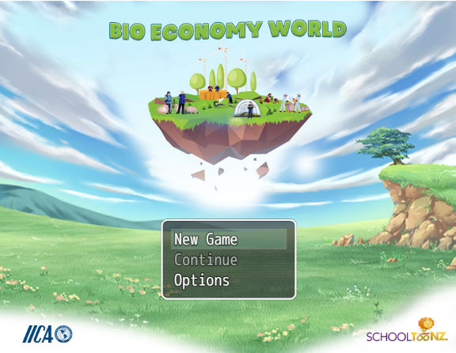

Kingston, March 13, 2023 (IICA) - Bio-Economy World is an educational product using game design elements to make learning fun and interactive. The course teaches about the bio-economy, a sustainable model for current and future production systems. Users will learn about environmental sustainability, modern agricultural practices and green business opportunities.
The gamified course is free for all users and can be accessed from the Internet via the following link:
https://decarteret-gaming-ia.itch.io/biomountains1

Do read and understand the instructions at the beginning of the course. You can go over the instructions if needed.
For additional information or if you have any queries, please contact: shauna.brandon@iica.int

